Fabian Hart

E-Mail: fabian.hart@tu-dresden.de

Internet: http://osv.vkw.tu-dresden.de

|  |  |
| --- | --- |
| |  | | --- | | Prof. Dr. Chandra R. BhatThe University of Texas at Austin 77 Massachusetts Avenue 301 E. Dean Keeton St. Stop C1761 Austin, Texas 78712 | |

Dear Prof. Dr. Chandra R. Bhat,

together with Ostap Okhrin and Martin Treiber we herewith submit an original research article entitled “*Formulation and validation of a car-following model based on deep reinforcement learning*” for consideration by *Transportation Research Part B*.

The paper is containing original research and has not been submitted/published earlier in any journal and is not being considered for publication elsewhere. All authors have seen and approved the manuscript and have contributed significantly to the paper.

Our research meets all applicable ethical standards with regard to the ethics of research integrity.

We propose a novel car-following model based on reinforcement learning. The objective is to maximize a general reward function rather than reproducing recorded trajectories. This approach allows using artificial leader's trajectories with unlimited data supply for the learning phase. The trained model validates well in new situations: string stability in platooning situations and a collision-free behavior in safety-critical situations such as a full-braking maneuver of the leader. The parameters of the reward function encode different driving styles, thereby lifting part of the black-box nature inherent in machine learning. When using the parameters of a conventional car-following model calibrated to observed leader-follower pairs, our proposed model behaved similarly but had better performance and validation metrics.

The authors declare that they have no known competing financial interests or personal relationships that could have appeared to influence the work reported in this paper.

Please address all correspondence concerning this manuscript to me at fabian.hart@tu-dresden.de.

Thank you for your consideration of this manuscript.

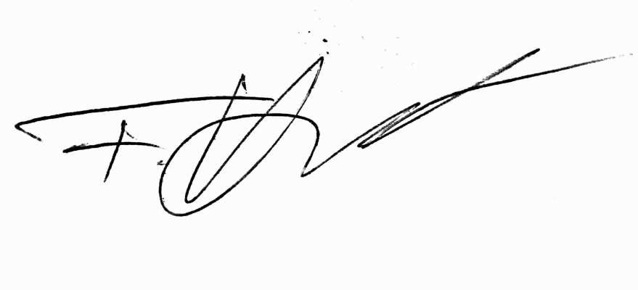

Fabian Hart Dresden, 23 September 2021